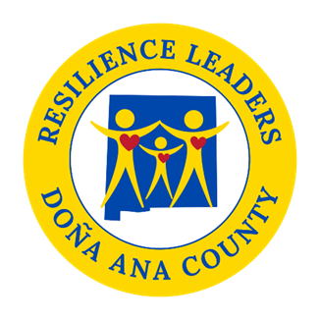

**Power Hour**

**Resilience Sector Leaders Agenda**

**Friday, January 10, 2025**

**2:00 pm to 3:00 pm**

Come join us **in person** **at DACRL new headquarters 520 N. Campo St.**

As always if you cannot make it there is a zoom option.

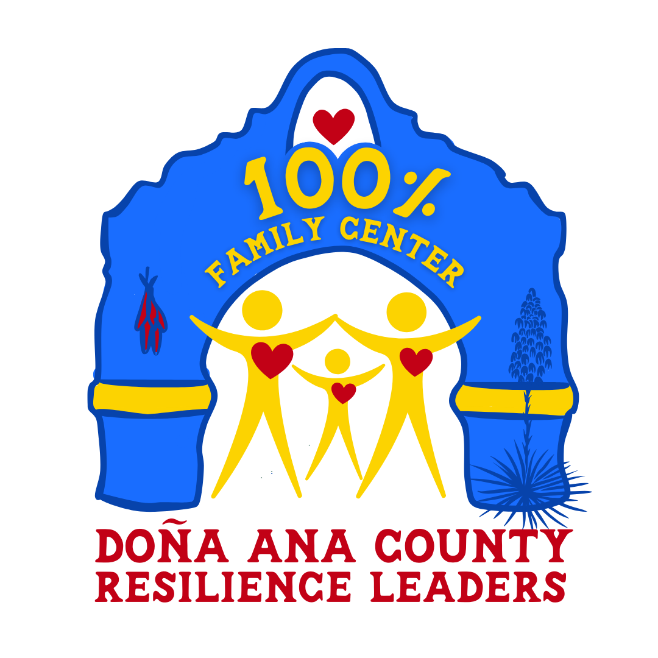

* **Welcome**
* **Update 100% Family Center**

-**Hiring Committee**

**- Training Abriendo Puertas**

**- Creation of Resource schedule @ RRFB**

* **Next Steps with Survey**
* **Youth Mentoring Month**

**- Bullying Summit Information**

**Next meeting: February 14th, 2025, from 2pm to 3pm.**

Topic: DACRL Power Hour (New Zoom Link)

Time: Jun 14, 2024 02:00 PM Mountain Time (US and Canada)

Every month on the Second Friday

Jul 12, 2024 02:00 PM

Aug 9, 2024 02:00 PM

Sep 13, 2024 02:00 PM

Oct 11, 2024 02:00 PM

Nov 8, 2024 02:00 PM

Dec 13, 2024 02:00 PM

Join Zoom Meeting

<https://us02web.zoom.us/j/87652034178?pwd=CI6ukNPt6D97txHrAbf3uKPKaD0nWV.1>

Meeting ID: 876 5203 4178

Passcode: 482609