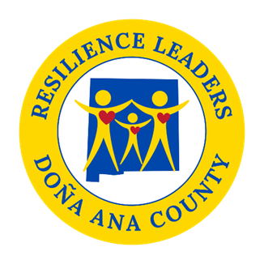

**Power Hour**

**Resilience Sector Leaders Agenda**

**Friday, March 21, 2025**

**12:00 pm to 1:00 pm**

Come join us **in person** **at DACRL new headquarters 520 N. Campo St.**

As always if you cannot make it there is a zoom option. 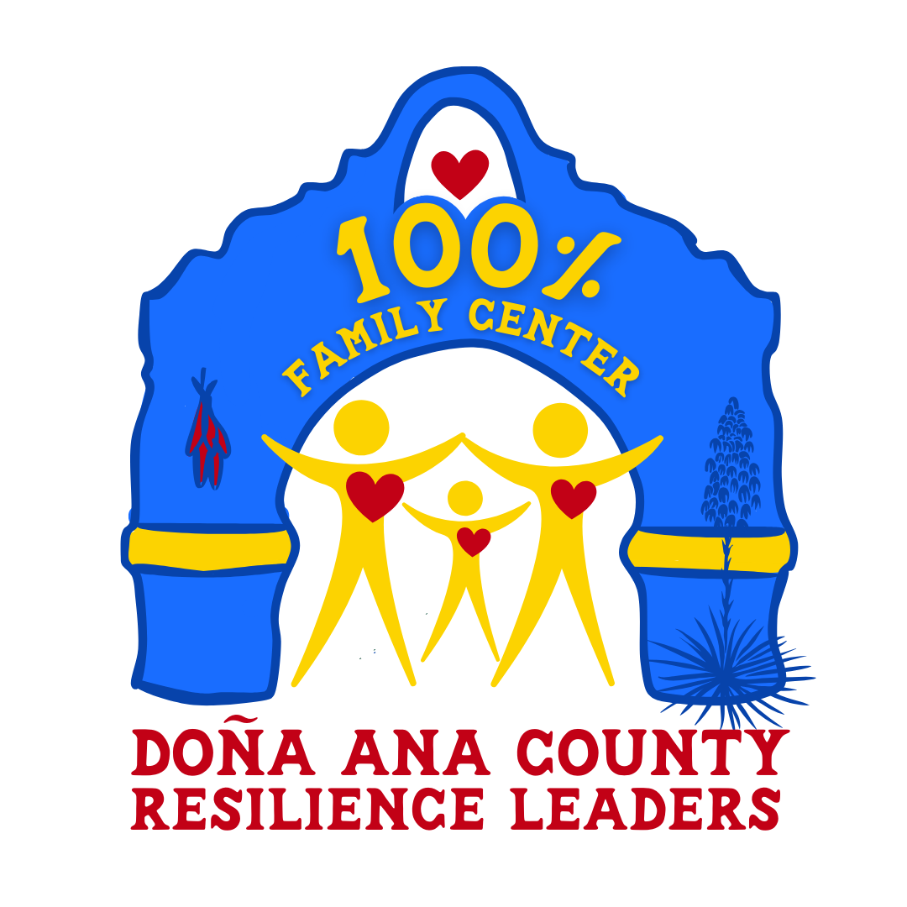

* **Welcome**
* **Update 100% Family Center**

**- New Staff**

**- Contracts with CFSNM**

**-Open House- flyers**

* **Update on Symbify and Unite Us**
* **Power Hour time**

**Next meeting: April 11th, 2025, from 2pm to 3pm.**

Topic: DACRL Power Hour (New Zoom Link)

Date/Time: :Every month on the Second Friday at 2 pm

Join Zoom Meeting

<https://us02web.zoom.us/j/87652034178?pwd=CI6ukNPt6D97txHrAbf3uKPKaD0nWV.1>

Meeting ID: 876 5203 4178

Passcode: 482609